

**WEB PAGE DESIGN USING HTML5 AND CSS3 (ASSESSMENT - 1)**

**CSE2015(INTERNET AND WEB PROGRAMMING)LAB:L31-L32**



**January 24, 2022**

**rajarshi saha**

**20BCT0163**

**QUESTION:**

**• Design a web page for your School (CBSE/HSC/Junior college)/Company using HTML5+ CSS3 (sample layout given below)**

**Tags:**

1. Home – about school - Image Map for school/company map
2. Group/Courses offered along with department name – Drop Down List – Use CSS selectors/combinators
3. Department/cultural Activities
   1. Upcoming events
   2. About clubs – embed related emojis
   3. Student achievements (embed paper cuttings img/Video/Audio) – HTML5 tags
4. Your faculty details in table format
5. Competitive exam score/ Company accredited certificate – company details and previous year records (for ratings use input tags)
6. COE/Feedback form
   1. Exam time table/project – Use table, rowspan/colspan
   2. Result/feedback – use HTML5 form – Fields are name, password, DOB, email-id, Phone no and comment inputs(types/tags/pattern)

**Sample Layout:**

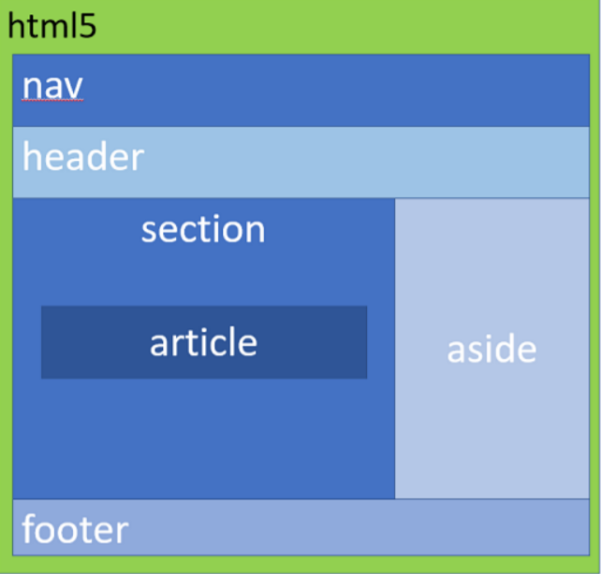

**Description:**

**HTML:**

HTML5 is a markup language used for structuring and presenting content on the World Wide Web. It is the fifth and last major HTML version that is a World Wide Web Consortium (W3C) recommendation. The current specification is known as the HTML Living Standard. It is maintained by the Web Hypertext Application Technology Working Group (WHATWG), a consortium of the major browser vendors (Apple, Google, Mozilla, and Microsoft).

**CSS:**

Cascading Style Sheets (CSS) is a style sheet language used for describing the look and formatting of a document written in a markup language. CSS3 is a latest standard of css earlier versions(CSS2).

**Home – about school - Image Map**

Code:

<!DOCTYPE html>

<html lang="en">

<head>

    <meta charset="UTF-8">

    <meta http-equiv="X-UA-Compatible" content="IE=edge">

    <meta name="viewport" content="width=device-width, initial-scale=1.0">

    <title>Exam Timetable</title>

    <link rel="stylesheet" href="style.css">

</head>

<body>

    <div id="menu" class="menu">

        <ul>

            <li class="dropdown"><a href="index.html">Home</a>

                <div class="dropdown-content">

                    <a href="index.html#about-us">About Us</a>

                    <a href="index.html#image-map">Campus</a>

                </div>

            </li>

            <li class="dropdown"><a href="courses.html">Schools</a>

                <div class="dropdown-content">

                    <a href="courses.html#pp">Pre-Primary Section</a>

                    <a href="courses.html#pri">Primary Section</a>

                    <a href="courses.html#high">High Section</a>

                    <a href="courses.html#hs">Higher Secondary Section</a>

                </div>

            </li>

            <li class="dropdown"><a href="clubs.html">Cultural Activities</a>

                <div class="dropdown-content">

                    <a href="clubs.html#events">Upcoming Events</a>

                    <a href="clubs.html#clubs">Clubs and Chapters</a>

                    <a href="clubs.html#glory">Hall of Fame</a>

                </div>

            </li>

            <li class="dropdown"><a href="faculty.html">Faculty Details</a>

                <div class="dropdown-content">

                    <a href="faculty.html#pp">Pre-Primary Section</a>

                    <a href="faculty.html#pri">Primary Section</a>

                    <a href="faculty.html#high">High Section</a>

                    <a href="faculty.html#hs">Higher Secondary Section</a>

                </div>

            </li>

            <li class="dropdown"><a href="results.html" class="active">Student Achievements</a>

                <div class="dropdown-content">

                    <a href="results.html#comp">Competitive Exams</a>

                    <a href="results.html#boards">Boards</a>

                    <a href="results.html#sports">Sports</a>

                    <a href="results.html#glory">Others</a>

                </div>

            </li>

            <li class="dropdown"><a href="coe.html">Student Login</a>

                <div class="dropdown-content">

                    <a href="coe.html#timetable">Timetable</a>

                    <a href="result.html#result">Result</a>

                  </div>

            </li>

            <li style="float:right" id="logo"><a class="logo" href="index.html"><img src="logo_hv_edited.jpg" width=20" height="30" alt="HVM logo" ></a></li>

        </ul>

    </div>

    <br><br><br><br>

    <div id="comp" class="leftcolumn">

        <div class="card">

            <center><p class="heading">Competitive Exams</p></center>

            <div id="marquee">

            <marquee scrollamount="9" scrolldelay="400" width="100%" height="700px" direction="up" onmouseover="stop();" onmouseout="start();" >

            <center>

            <p>JEE Mains Results 2021:</p>

            <p> Anirudh Vadera: 99.92 percentile</p>

            <p>State Rank: 1</p>

            <p>Marks Scored: 342/360</p>

            <p></p>

            <p> Mayukh Mondal: 99.71 percentile</p>

            <p>State Rank: 10</p>

            <p>Marks Scored: 322/360</p>

            <p></p>

            <p> Vansh Karnwal: 99.11 percentile</p>

            <p>State Rank: 29</p>

            <p>Marks Scored: 302/360</p>

            <p></p>

            <p>&nbsp;</p>

            <p>NEET Results 2021:</p>

            <p> Arshiya Vadera: 99.92 percentile</p>

            <p>State Rank: 1</p>

            <p>Marks Scored: 342/360</p>

            <p></p>

            <p> Mayushi Mondal: 99.71 percentile</p>

            <p>State Rank: 10</p>

            <p>Marks Scored: 322/360</p>

            <p></p>

            <p>&nbsp;</p>

            </center>

            </marquee>

        </div>

        </div>

    </div>

    <div id="boards" class="leftcolumn">

        <div class="boards">

            <center><p class="heading">Boards</p></center>

            <div id="marquee">

            <marquee scrollamount="9" scrolldelay="400" width="100%" height="700px" direction="up" onmouseover="stop();" onmouseout="start();" >

            <center>

            <p>Class 10 Results 2021:</p>

            <p> Anirudh Vadera: 99.92 percentile</p>

            <p>State Rank: 1</p>

            <p>Marks Scored: 342/360</p>

            <p></p>

            <p>&nbsp;</p>

            <p>Class 12 Results 2021:</p>

            <p> Arshiya Dwiwedi: 99.92 percentile</p>

            <p>State Rank: 1</p>

            <p>Marks Scored: 342/360</p>

            <p></p>

            <p>&nbsp;</p>

            </center>

            </marquee>

        </div>

        </div>

    </div>

    <div id="sports" class="rightcolumn">

        <div class="boards">

            <center><p class="heading">Sports</p></center>

            <div id="marquee">

            <marquee scrollamount="9" scrolldelay="400" width="100%" height="700px" direction="up" onmouseover="stop();" onmouseout="start();" >

            <center>

            <p>RFYCResults 2021:</p>

            <p>HVM Football Team</p>

            <p>State Rank: 5</p>

            <p></p>

            <p>&nbsp;</p>

            </center>

            </marquee>

        </div>

        </div>

    </div>

    <div id="glory" class="rightcolumn">

        <div class="boards">

            <center><p class="heading">Others</p></center>

            <div id="marquee">

            <marquee scrollamount="9" scrolldelay="400" width="100%" height="700px" direction="up" onmouseover="stop();" onmouseout="start();" >

            <center>

            <p>Spell BEE 2021:</p>

            <p>HVM Team</p>

            <p>State Rank: 1</p>

            <p></p>

            <p>&nbsp;</p>

            </center>

            </marquee>

        </div>

        </div>

    </div>

Output:

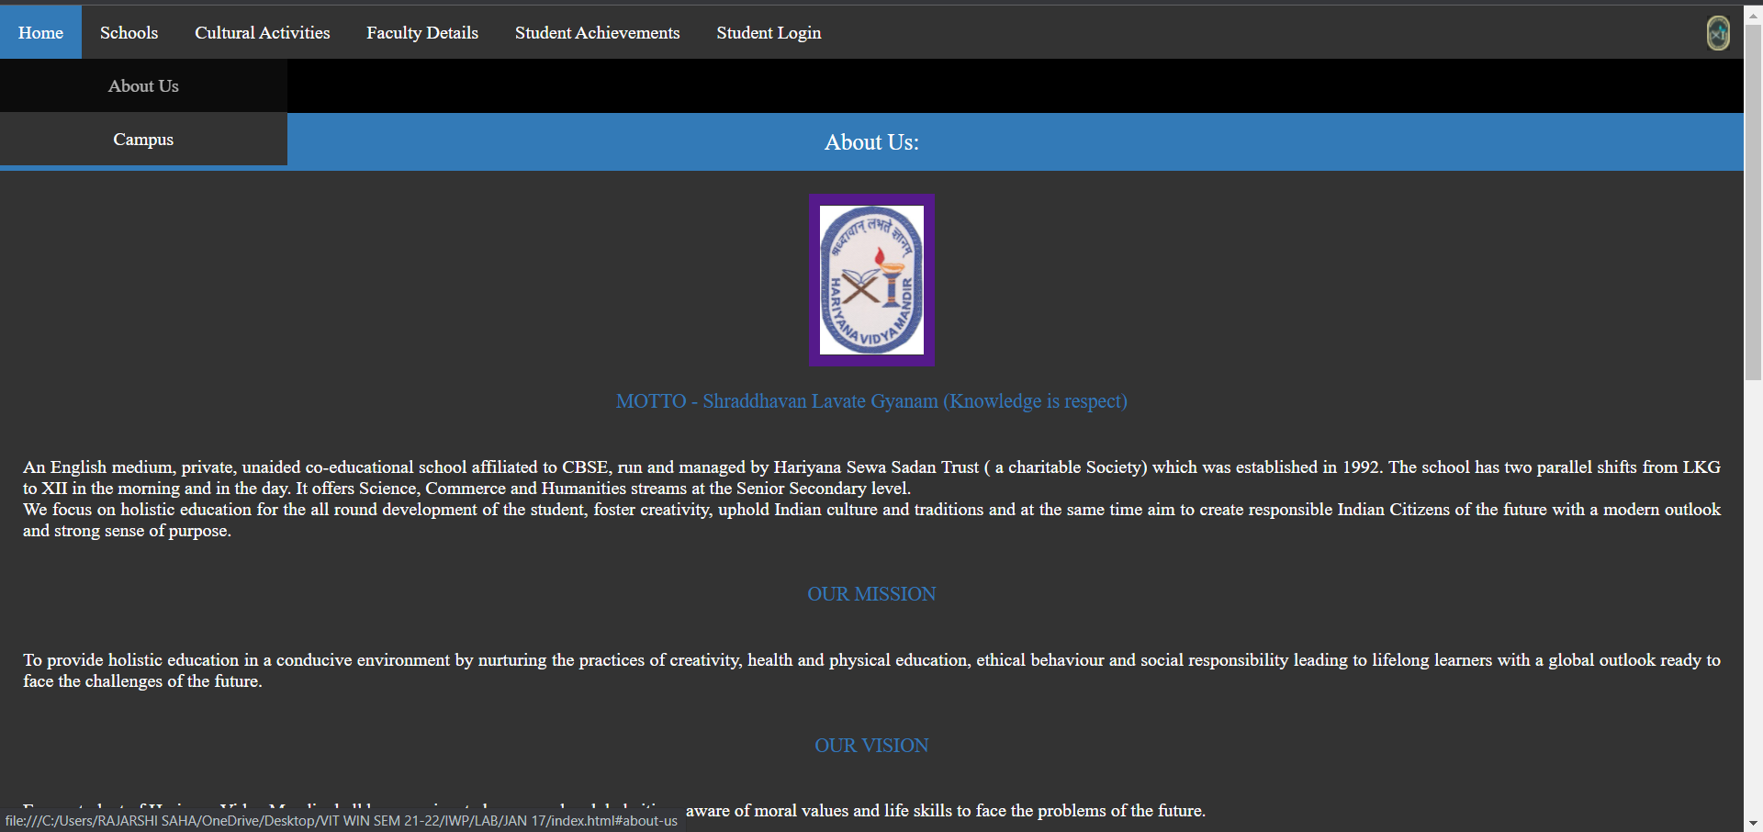

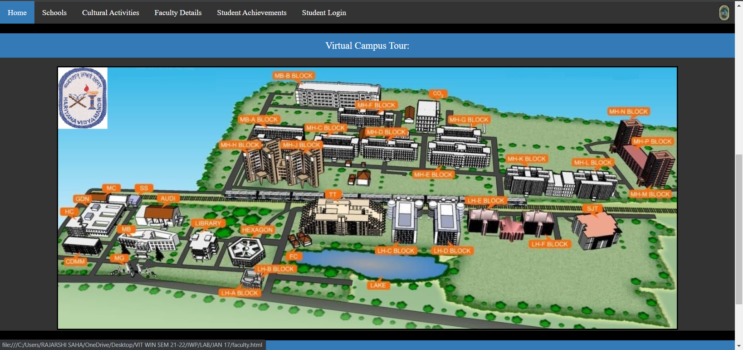

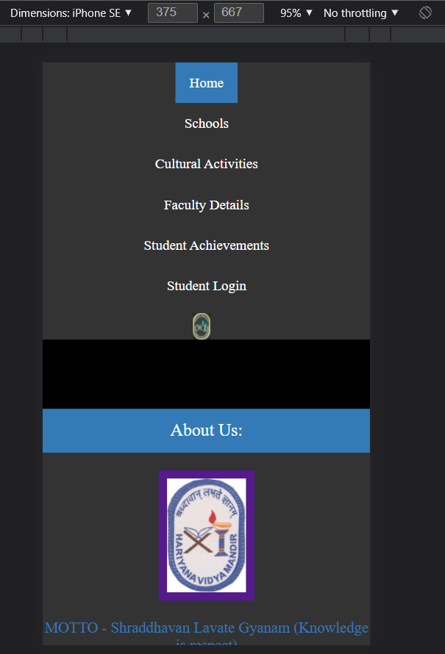

Group/Courses offered along with department name – Drop Down List – Use CSS selectors/combinators

Code:

<!DOCTYPE html>

<html lang="en">

<head>

    <meta charset="UTF-8">

    <meta http-equiv="X-UA-Compatible" content="IE=edge">

    <meta name="viewport" content="width=device-width, initial-scale=1.0">

    <title>HVM Courses</title>

    <link rel="icon" href="logo_hv.jpg">

    <link rel="stylesheet" href="https://cdnjs.cloudflare.com/ajax/libs/font-awesome/4.7.0/css/font-awesome.min.css">

    <link rel="stylesheet" href="style.css">

</head>

<body>

    <div id="menu" class="menu">

        <ul>

            <li class="dropdown"><a href="index.html">Home</a>

                <div class="dropdown-content">

                    <a href="index.html#about-us">About Us</a>

                    <a href="index.html#image-map">Campus</a>

                </div>

            </li>

            <li class="dropdown"><a href="courses.html" class="active">Schools</a>

                <div class="dropdown-content">

                    <a href="courses.html#pp">Pre-Primary Section</a>

                    <a href="courses.html#pri">Primary Section</a>

                    <a href="courses.html#high">High Section</a>

                    <a href="courses.html#hs">Higher Secondary Section</a>

                </div>

            </li>

            <li class="dropdown"><a href="clubs.html">Cultural Activities</a>

                <div class="dropdown-content">

                    <a href="clubs.html#events">Upcoming Events</a>

                    <a href="clubs.html#clubs">Clubs and Chapters</a>

                    <a href="clubs.html#glory">Hall of Fame</a>

                </div>

            </li>

            <li class="dropdown"><a href="faculty.html">Faculty Details</a>

                <div class="dropdown-content">

                    <a href="faculty.html#pp">Pre-Primary Section</a>

                    <a href="faculty.html#pri">Primary Section</a>

                    <a href="faculty.html#high">High Section</a>

                    <a href="faculty.html#hs">Higher Secondary Section</a>

                </div>

            </li>

            <li class="dropdown"><a href="results.html">Student Achievements</a>

                <div class="dropdown-content">

                    <a href="results.html#comp">Competitive Exams</a>

                    <a href="results.html#boards">Boards</a>

                    <a href="results.html#sports">Sports</a>

                    <a href="clubs.html#glory">Others</a>

                </div>

            </li>

            <li class="dropdown"><a href="coe.html">Student Login</a>

            <div class="dropdown-content">

              <a href="coe.html#timetable">Timetable</a>

              <a href="result.html#result">Result</a>

            </div>

            </li>

            <li style="float:right" id="logo"><a class="logo" href="index.html"><img src="logo_hv_edited.jpg" width=20" height="30" alt="HVM logo" ></a></li>

        </ul>

    </div>

    <br><br><br><br>

    <div class="card" id="#pp">

        <center><p class="heading">Pre-Primary Section & Primary</p></center>

        <div id="clubs">

            <div>

                <center><img class="map" src="pp1.jpg" width="100%" alt="banss"/></center>

            </div>

            <div>

                <center><img class="map" src="pp2.jfif" width="100%"  alt="banss"/></center>

            </div>

            <div>

                <center><img class="map" src="primary1.jfif" width="100%"  alt="banss"/></center>

            </div>

            <div>

                <center><img class="map" src="primary2.jfif" width="100%" alt="banss"/></center>

            </div>

        </div>

        <br>

        <br>

        <table border="5" border="double" cellspacing="5px" class="table">

            <tr>

                <th>Sno.</th>

                <th>Subject</th>

                <th>Class</th>

            </tr>

            <tr id="pp">

                <td>1</td>

                <td>English</td>

                <td rowspan="3">Pre-Primary<br>(Nursey,LKG, UKG)</td>

            </tr>

            <tr>

                <td>2</td>

                <td>Arts & Crafts</td>

            </tr>

            <tr>

                <td>3</td>

                <td>Maths</td>

            </tr>

            <tr id="pri">

                <td>4</td>

                <td>English</td>

                <td rowspan="4">Primart<br>(I to IV)</td>

            </tr>

            <tr>

                <td>5</td>

                <td>Social Studies</td>

            </tr>

            <tr>

                <td>6</td>

                <td>Science</td>

            </tr>

            <tr>

                <td>7</td>

                <td>Maths</td>

            </tr>

        </table>

    </div>

    <div class="card" id="#pp">

        <center><p class="heading">High Section & Higher Secondary</p></center>

        <div id="clubs">

            <div>

                <center><img class="map" src="high1.jfif" width="100%" alt="banss"/></center>

            </div>

            <div>

                <center><img class="map" src="high2.jfif" width="100%" alt="banss"/></center>

            </div>

            <div>

                <center><img class="map" src="hs1.jfif" width="100%" alt="banss"/></center>

            </div>

            <div>

                <center><img class="map" src="hs2.jfif" width="100%" alt="banss"/></center>

            </div>

        </div>

        <br>

        <br>

        <table border="5" border="double" cellspacing="5px" class="table">

            <tr>

                <th>Sno.</th>

                <th>Subject</th>

                <th>Class</th>

            </tr>

            <tr>

                <td>1</td>

                <td>English</td>

                <td rowspan="4">Classes<br>V to VIII</td>

            </tr>

            <tr>

                <td>2</td>

                <td>Social Studies</td>

            </tr>

            <tr>

                <td>3</td>

                <td>Science</td>

            </tr>

            <tr>

                <td>4</td>

                <td>Maths</td>

            </tr>

            <tr>

                <td>5</td>

                <td>English</td>

                <td rowspan="7">Classes<br>IX,X<br>XI,XII</td>

            </tr>

            <tr>

                <td>6</td>

                <td>Social Studies</td>

            </tr>

            <tr>

                <td>7</td>

                <td>Physics</td>>

            </tr>

            <tr>

                <td>8</td>

                <td>Maths</td>

            </tr>

            <tr>

                <td>9</td>

                <td>Chemistry</td>

            </tr>

            <tr>

                <td>10</td>

                <td>Biology</td>

            </tr>

            <tr>

                <td>11</td>

                <td>Computer Science</td>

            </tr>

        </table>

    </div>

    <div id="eop" class="map"><p class="sec"></p></div>

    <footer>

        <center><img src="footer_logo.jpg" width=66% height="150" alt="footer"></center>

    </footer>

</body>

</html>

Output:

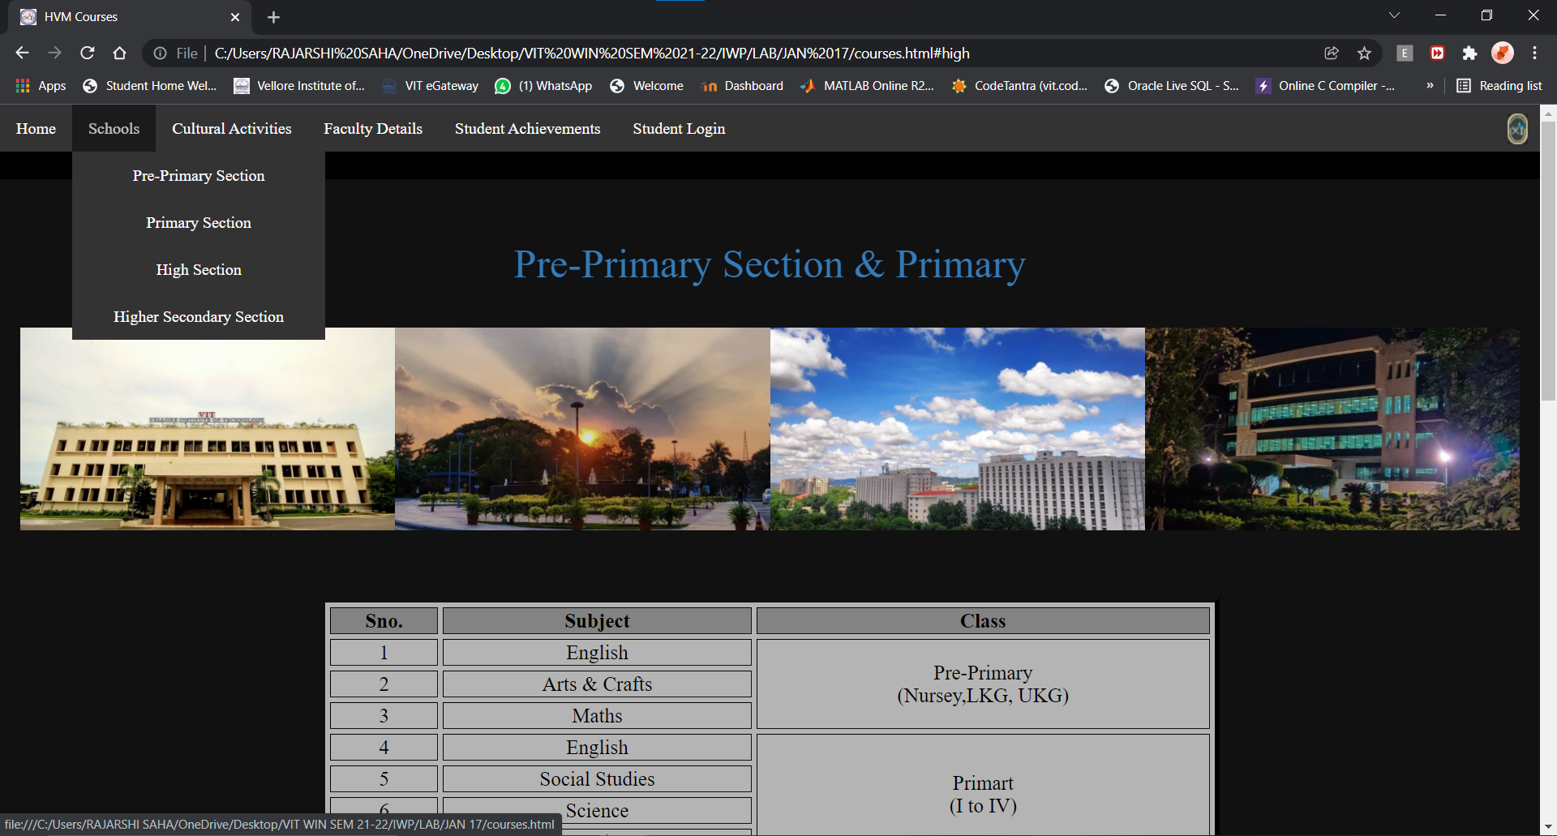

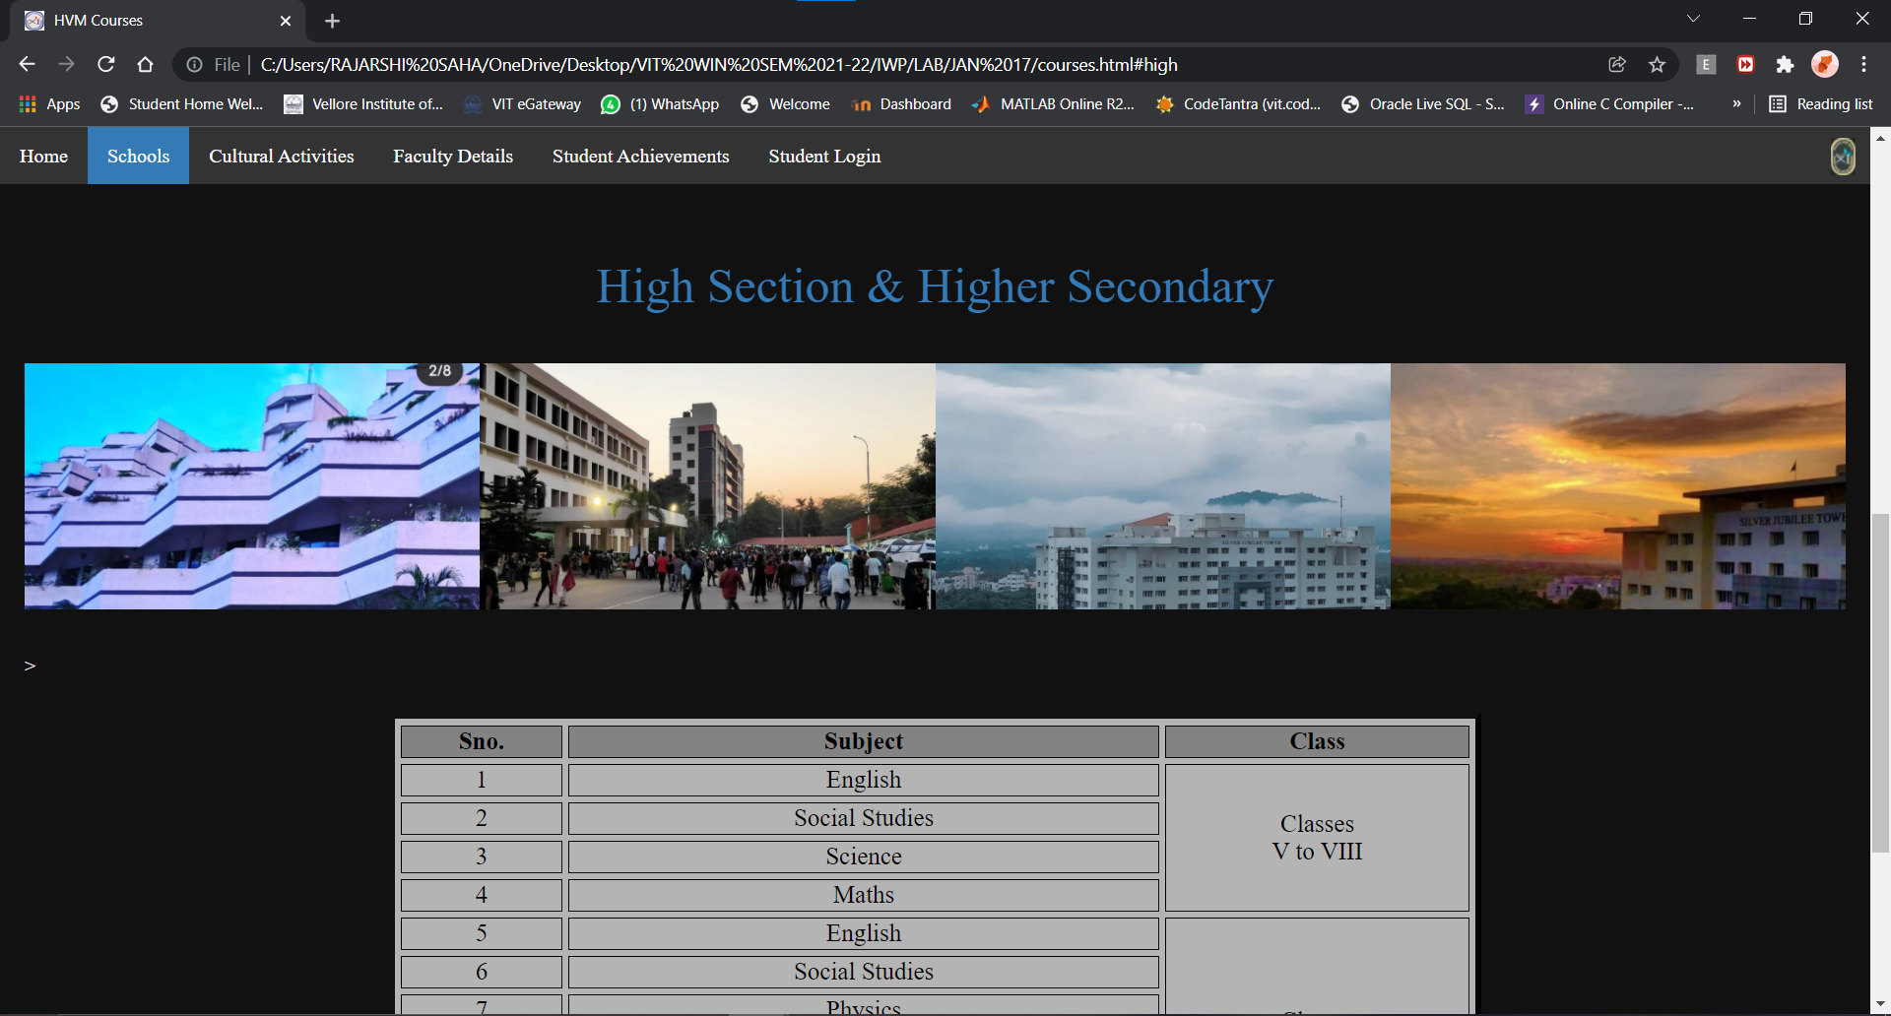

**Note: Picture Gallery is animated using css**

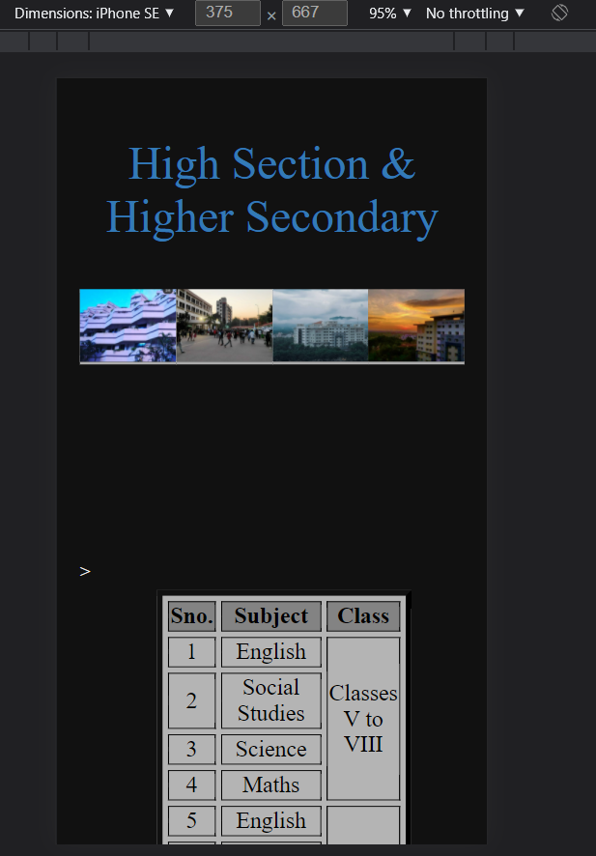

Department/cultural Activities

* 1. Upcoming events
  2. About clubs – embed related emojis
  3. Student achievements (embed paper cuttings img/Video/Audio) – HTML5 tags

Code:

<!DOCTYPE html>

<html lang="en">

<head>

    <meta charset="UTF-8">

    <meta http-equiv="X-UA-Compatible" content="IE=edge">

    <meta name="viewport" content="width=device-width, initial-scale=1.0">

    <title>HVM Courses</title>

    <link rel="icon" href="logo_hv.jpg">

    <link rel="stylesheet" href="https://cdnjs.cloudflare.com/ajax/libs/font-awesome/4.7.0/css/font-awesome.min.css">

    <link rel="stylesheet" href="style.css">

</head>

<body>

    <div id="menu" class="menu">

        <ul>

            <li class="dropdown"><a href="index.html">Home</a>

                <div class="dropdown-content">

                    <a href="index.html#about-us">About Us</a>

                    <a href="index.html#image-map">Campus</a>

                </div>

            </li>

            <li class="dropdown"><a href="courses.html" class="active">Schools</a>

                <div class="dropdown-content">

                    <a href="courses.html#pp">Pre-Primary Section</a>

                    <a href="courses.html#pri">Primary Section</a>

                    <a href="courses.html#high">High Section</a>

                    <a href="courses.html#hs">Higher Secondary Section</a>

                </div>

            </li>

            <li class="dropdown"><a href="clubs.html">Cultural Activities</a>

                <div class="dropdown-content">

                    <a href="clubs.html#events">Upcoming Events</a>

                    <a href="clubs.html#clubs">Clubs and Chapters</a>

                    <a href="clubs.html#glory">Hall of Fame</a>

                </div>

            </li>

            <li class="dropdown"><a href="faculty.html">Faculty Details</a>

                <div class="dropdown-content">

                    <a href="faculty.html#pp">Pre-Primary Section</a>

                    <a href="faculty.html#pri">Primary Section</a>

                    <a href="faculty.html#high">High Section</a>

                    <a href="faculty.html#hs">Higher Secondary Section</a>

                </div>

            </li>

            <li class="dropdown"><a href="results.html">Student Achievements</a>

                <div class="dropdown-content">

                    <a href="results.html#comp">Competitive Exams</a>

                    <a href="results.html#boards">Boards</a>

                    <a href="results.html#sports">Sports</a>

                    <a href="clubs.html#glory">Others</a>

                </div>

            </li>

            <li class="dropdown"><a href="coe.html">Exams</a>

            <div class="dropdown-content">

              <a href="coe.html#timetable">Timetable</a>

              <a href="result.html#result">Result</a>

            </div>

            </li>

            <li style="float:right" id="logo"><a class="logo" href="index.html"><img src="logo_hv_edited.jpg" width=20" height="30" alt="HVM logo" ></a></li>

        </ul>

    </div>

    <br><br><br><br>

    <div class="card" style="overflow: auto;">

        <center><p class="heading">Pre-Primary Section & Primary</p></center>

        <div id="imgs">

            <div>

                <center><img class="map" src="pp1.jpg" width="100%" height="100%" alt="banss"/></center>

            </div>

            <div>

                <center><img class="map" src="pp2.jfif" width="100%" height="100%"  alt="banss"/></center>

            </div>

            <div>

                <center><img class="map" src="primary1.jfif" width="100%" height="100%" alt="banss"/></center>

            </div>

            <div>

                <center><img class="map" src="primary2.jfif" width="100%" height="100%" alt="banss"/></center>

            </div>

        </div>

        <table border="5" border="double" cellspacing="5px" class="table">

            <tr>

                <th>Sno.</th>

                <th>Subject</th>

                <th>Class</th>

            </tr>

            <tr id="pp">

                <td>1</td>

                <td>English</td>

                <td rowspan="3">Pre-Primary<br>(Nursey,LKG, UKG)</td>

            </tr>

            <tr>

                <td>2</td>

                <td>Arts & Crafts</td>

            </tr>

            <tr>

                <td>3</td>

                <td>Maths</td>

            </tr>

            <tr id="pri">

                <td>4</td>

                <td>English</td>

                <td rowspan="4">Primart<br>(I to IV)</td>

            </tr>

            <tr>

                <td>5</td>

                <td>Social Studies</td>

            </tr>

            <tr>

                <td>6</td>

                <td>Science</td>

            </tr>

            <tr>

                <td>7</td>

                <td>Maths</td>

            </tr>

        </table>

    </div>

    <div class="card">

        <center><p class="heading">High Section & Higher Secondary</p></center>

        <div id="imgs">

            <div>

                <center><img class="map" src="high1.jfif" width="100%" height="100%" alt="banss"/></center>

            </div>

            <div>

                <center><img class="map" src="high2.jfif" width="100%" height="100%" alt="banss"/></center>

            </div>

            <div>

                <center><img class="map" src="hs1.jfif" width="100%" height="100%" alt="banss"/></center>

            </div>

            <div>

                <center><img class="map" src="hs2.jfif" width="100%" height="100%" alt="banss"/></center>

            </div>

        </div>

        <table border="5" border="double" cellspacing="5px" class="table">

            <tr>

                <th>Sno.</th>

                <th>Subject</th>

                <th>Class</th>

            </tr>

            <tr>

                <td>1</td>

                <td>English</td>

                <td rowspan="4">Classes<br>V to VIII</td>

            </tr>

            <tr>

                <td>2</td>

                <td>Social Studies</td>

            </tr>

            <tr>

                <td>3</td>

                <td>Science</td>

            </tr>

            <tr>

                <td>4</td>

                <td>Maths</td>

            </tr>

            <tr>

                <td>5</td>

                <td>English</td>

                <td rowspan="7">Classes<br>IX,X<br>XI,XII</td>

            </tr>

            <tr>

                <td>6</td>

                <td>Social Studies</td>

            </tr>

            <tr>

                <td>7</td>

                <td>Physics</td>>

            </tr>

            <tr>

                <td>8</td>

                <td>Maths</td>

            </tr>

            <tr>

                <td>9</td>

                <td>Chemistry</td>

            </tr>

            <tr>

                <td>10</td>

                <td>Biology</td>

            </tr>

            <tr>

                <td>11</td>

                <td>Computer Science</td>

            </tr>

        </table>

    </div>

    <div id="eop" class="map"><p class="sec"></p></div>

    <footer>

        <center><img src="footer_logo.jpg" width=66% height="150" alt="footer"></center>

    </footer>

</body>

</html>

Output:

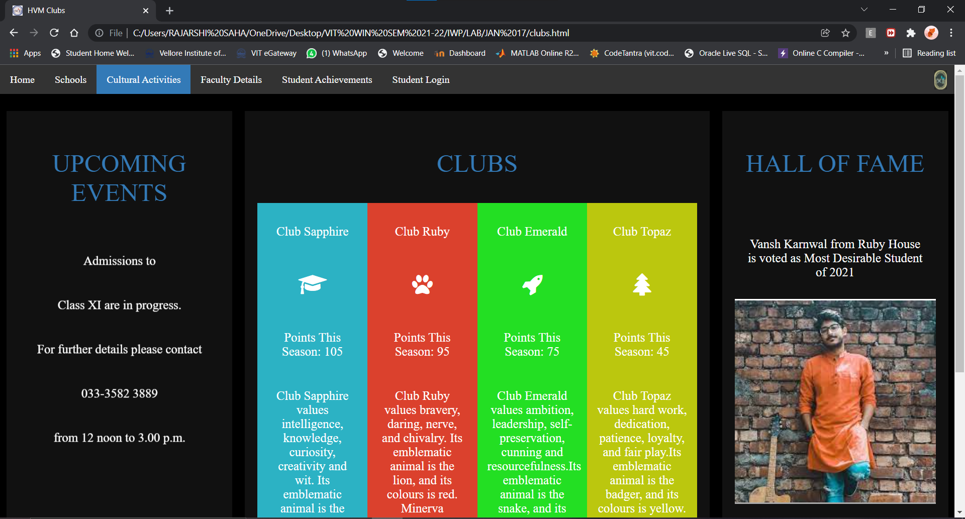

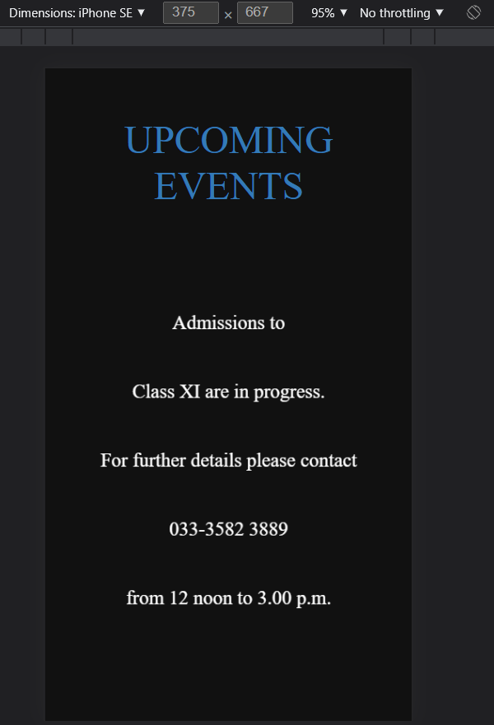

Your faculty details in table format

Code:

<!DOCTYPE html>

<html>

<head>

  <meta charset="UTF-8">

  <meta http-equiv="X-UA-Compatible" content="IE=edge">

  <meta name="viewport" content="width=device-width, initial-scale=1.0">

  <title>HVM Faculty</title>

  <link rel="stylesheet" href="style.css">

</head>

<body>

  <div id="menu" class="menu">

    <ul>

        <li class="dropdown"><a href="index.html">Home</a>

            <div class="dropdown-content">

                <a href="index.html#about-us">About Us</a>

                <a href="index.html#image-map">Campus</a>

            </div>

        </li>

        <li class="dropdown"><a href="courses.html">Schools</a>

            <div class="dropdown-content">

                <a href="courses.html#pp">Pre-Primary Section</a>

                <a href="courses.html#pri">Primary Section</a>

                <a href="courses.html#high">High Section</a>

                <a href="courses.html#hs">Higher Secondary Section</a>

            </div>

        </li>

        <li class="dropdown"><a href="clubs.html">Cultural Activities</a>

            <div class="dropdown-content">

                <a href="clubs.html#events">Upcoming Events</a>

                <a href="clubs.html#clubs">Clubs and Chapters</a>

                <a href="clubs.html#glory">Hall of Fame</a>

            </div>

        </li>

        <li class="dropdown"><a href="faculty.html" class="active">Faculty Details</a>

            <div class="dropdown-content">

                <a href="faculty.html#pp">Pre-Primary Section</a>

                <a href="faculty.html#pri">Primary Section</a>

                <a href="faculty.html#high">High Section</a>

                <a href="faculty.html#hs">Higher Secondary Section</a>

            </div>

        </li>

        <li class="dropdown"><a href="results.html">Student Achievements</a>

            <div class="dropdown-content">

                <a href="results.html#comp">Competitive Exams</a>

                <a href="results.html#boards">Boards</a>

                <a href="results.html#sports">Sports</a>

                <a href="clubs.html#glory">Others</a>

            </div>

        </li>

        <li class="dropdown"><a href="coe.html">Exams</a>

          <div class="dropdown-content">

            <a href="coe.html#timetable">Timetable</a>

            <a href="result.html#result">Result</a>

          </div>

        </li>

        <li style="float:right" id="logo"><a class="logo" href="index.html"><img src="logo_hv_edited.jpg" width=20" height="30" alt="HVM logo" ></a></li>

    </ul>

  </div>

<br><br><br><br>

<div id="principal" class="faculty-bck">

  <p class="faculty-sec">PRINCIPAL DETAILS</p>

  <div class="princ_card">

    <img src="https://img.icons8.com/cotton/256/000000/female-teacher--v2.png"/>

    <h3>Dr.SANGHAMITRA BANERJEE</h3>

    <div style="margin: 24px 0;">

      <a href="#"><i class="fa fa-dribbble fa-2x"></i></a>

      <a href="#"><i class="fa fa-twitter fa-2x"></i></a>

      <a href="#"><i class="fa fa-linkedin fa-2x"></i></a>

      <a href="#"><i class="fa fa-facebook fa-2x"></i></a>

    </div>

    <p><button>Contact</button></p>

  </div>

</div>

<div id="pp" class="faculty-bck">

  <p class="faculty-sec">Pre-Primary Section</p>

  <div class="fac_card">

    <img src="https://img.icons8.com/emoji/96/000000/woman-teacher.png"/>

    <h3>ANANYA MITRA</h3>

    <p class="faculty-txt">English</p>

    <p class="faculty-txt">Asst. Teacher</p>

    <div style="margin: 24px 0;">

      <a href="#"><i class="fa fa-dribbble"></i></a>

      <a href="#"><i class="fa fa-twitter"></i></a>

      <a href="#"><i class="fa fa-linkedin"></i></a>

      <a href="#"><i class="fa fa-facebook"></i></a>

    </div>

    <p><button>Contact</button></p>

  </div>

  <div class="fac_card"">

    <img src="https://img.icons8.com/emoji/96/000000/woman-teacher.png"/>

    <h3>PAPIYA BASU</h3>

    <p class="faculty-txt">Hindi</p>

    <p class="faculty-txt">Asst. Teacher</p>

    <div style="margin: 24px 0;">

      <a href="#"><i class="fa fa-dribbble"></i></a>

      <a href="#"><i class="fa fa-twitter"></i></a>

      <a href="#"><i class="fa fa-linkedin"></i></a>

      <a href="#"><i class="fa fa-facebook"></i></a>

    </div>

    <p><button>Contact</button></p>

  </div>

  <div class="fac_card">

    <img src="https://img.icons8.com/emoji/96/000000/woman-teacher.png"/>

    <h3>PAPIA DAS</h3>

    <p class="faculty-txt">Games</p>

    <p class="faculty-txt">Asst. Teacher</p>

    <div style="margin: 24px 0;">

      <a href="#"><i class="fa fa-dribbble"></i></a>

      <a href="#"><i class="fa fa-twitter"></i></a>

      <a href="#"><i class="fa fa-linkedin"></i></a>

      <a href="#"><i class="fa fa-facebook"></i></a>

    </div>

    <p><button>Contact</button></p>

  </div>

</div>

<div id="pri" class="faculty-bck">

  <p class="faculty-sec">Primary Section</p>

  <div class="fac_card">

    <img src="https://img.icons8.com/emoji/96/000000/woman-teacher.png"/>

    <h3>POOJA SAHA</h3>

    <p class="faculty-txt">Hindi</p>

    <p class="faculty-txt">PRT</p>

    <div style="margin: 24px 0;">

      <a href="#"><i class="fa fa-dribbble"></i></a>

      <a href="#"><i class="fa fa-twitter"></i></a>

      <a href="#"><i class="fa fa-linkedin"></i></a>

      <a href="#"><i class="fa fa-facebook"></i></a>

    </div>

    <p><button>Contact</button></p>

  </div>

  <div class="fac_card">

    <img src="https://img.icons8.com/emoji/96/000000/woman-teacher.png"/>

    <h3>KABITA SAHA</h3>

    <p class="faculty-txt">Evs</p>

    <p class="faculty-txt">PRT</p>

    <div style="margin: 24px 0;">

      <a href="#"><i class="fa fa-dribbble"></i></a>

      <a href="#"><i class="fa fa-twitter"></i></a>

      <a href="#"><i class="fa fa-linkedin"></i></a>

      <a href="#"><i class="fa fa-facebook"></i></a>

    </div>

    <p><button>Contact</button></p>

  </div>

  <div class="fac_card">

    <img src="https://img.icons8.com/emoji/96/000000/woman-teacher.png"/>

    <h3>MANJU JAIN</h3>

    <p class="faculty-txt">Maths</p>

    <p class="faculty-txt">PRT</p>

    <div style="margin: 24px 0;">

      <a href="#"><i class="fa fa-dribbble"></i></a>

      <a href="#"><i class="fa fa-twitter"></i></a>

      <a href="#"><i class="fa fa-linkedin"></i></a>

      <a href="#"><i class="fa fa-facebook"></i></a>

    </div>

    <p><button>Contact</button></p>

  </div>

</div>

<div id="high" class="faculty-bck">

  <p class="faculty-sec">High Section</p>

  <div class="fac_card">

    <img src="https://img.icons8.com/emoji/96/000000/woman-teacher.png"/>

    <h3>DIPTI BINANI</h3>

    <p class="faculty-txt">TGT</p>

    <p class="faculty-txt">English</p>

    <div style="margin: 24px 0;">

      <a href="#"><i class="fa fa-dribbble"></i></a>

      <a href="#"><i class="fa fa-twitter"></i></a>

      <a href="#"><i class="fa fa-linkedin"></i></a>

      <a href="#"><i class="fa fa-facebook"></i></a>

    </div>

    <p><button>Contact</button></p>

  </div>

  <div class="fac_card">

    <img src="https://img.icons8.com/emoji/96/000000/man-teacher.png"/>

    <h3>MISHA GUPTA</h3>

    <p class="faculty-txt">TGT</p>

    <p class="faculty-txt">Social Studies</p>

    <div style="margin: 24px 0;">

      <a href="#"><i class="fa fa-dribbble"></i></a>

      <a href="#"><i class="fa fa-twitter"></i></a>

      <a href="#"><i class="fa fa-linkedin"></i></a>

      <a href="#"><i class="fa fa-facebook"></i></a>

    </div>

    <p><button>Contact</button></p>

  </div>

  <div class="fac_card"">

    <img src="https://img.icons8.com/emoji/96/000000/man-teacher.png"/>

    <h3>MANASI SHEE</h3>

    <p class="faculty-txt">PGT</p>

    <p class="faculty-txt">Science</p>

    <div style="margin: 24px 0;">

      <a href="#"><i class="fa fa-dribbble"></i></a>

      <a href="#"><i class="fa fa-twitter"></i></a>

      <a href="#"><i class="fa fa-linkedin"></i></a>

      <a href="#"><i class="fa fa-facebook"></i></a>

    </div>

    <p><button>Contact</button></p>

  </div>

</div>

<div id="hs" class="faculty-bck">

  <p class="faculty-sec">Higher Secondary Section</p>

  <div class="fac_card">

    <img src="https://img.icons8.com/emoji/96/000000/woman-teacher.png"/>

    <h3>DORA SINHA</h3>

    <p class="faculty-txt">PGT</p>

    <p class="faculty-txt">Maths</p>

    <div style="margin: 24px 0;">

      <a href="#"><i class="fa fa-dribbble"></i></a>

      <a href="#"><i class="fa fa-twitter"></i></a>

      <a href="#"><i class="fa fa-linkedin"></i></a>

      <a href="#"><i class="fa fa-facebook"></i></a>

    </div>

    <p><button>Contact</button></p>

  </div>

  <div class="fac_card">

    <img src="https://img.icons8.com/emoji/96/000000/man-teacher.png"/>

    <h3>MANASI SHEE</h3>

    <p class="faculty-txt">PGT</p>

    <p class="faculty-txt">Biology</p>

    <div style="margin: 24px 0;">

      <a href="#"><i class="fa fa-dribbble"></i></a>

      <a href="#"><i class="fa fa-twitter"></i></a>

      <a href="#"><i class="fa fa-linkedin"></i></a>

      <a href="#"><i class="fa fa-facebook"></i></a>

    </div>

    <p><button>Contact</button></p>

  </div>

  <div class="fac_card">

    <img src="https://img.icons8.com/emoji/96/000000/man-teacher.png"/>

    <h3>SATHI ROY</h3>

    <p class="faculty-txt">PGT</p>

    <p class="faculty-txt">Chemistry</p>

    <div style="margin: 24px 0;">

      <a href="#"><i class="fa fa-dribbble"></i></a>

      <a href="#"><i class="fa fa-twitter"></i></a>

      <a href="#"><i class="fa fa-linkedin"></i></a>

      <a href="#"><i class="fa fa-facebook"></i></a>

    </div>

    <p><button>Contact</button></p>

  </div>

</div>

<div id="eop" class="map"><p class="sec"> </p></div>

<div>

    <center><img src="footer_logo.jpg" width=66% height="150" alt="footer"></center>

</div>

</body>

</html>

Output:

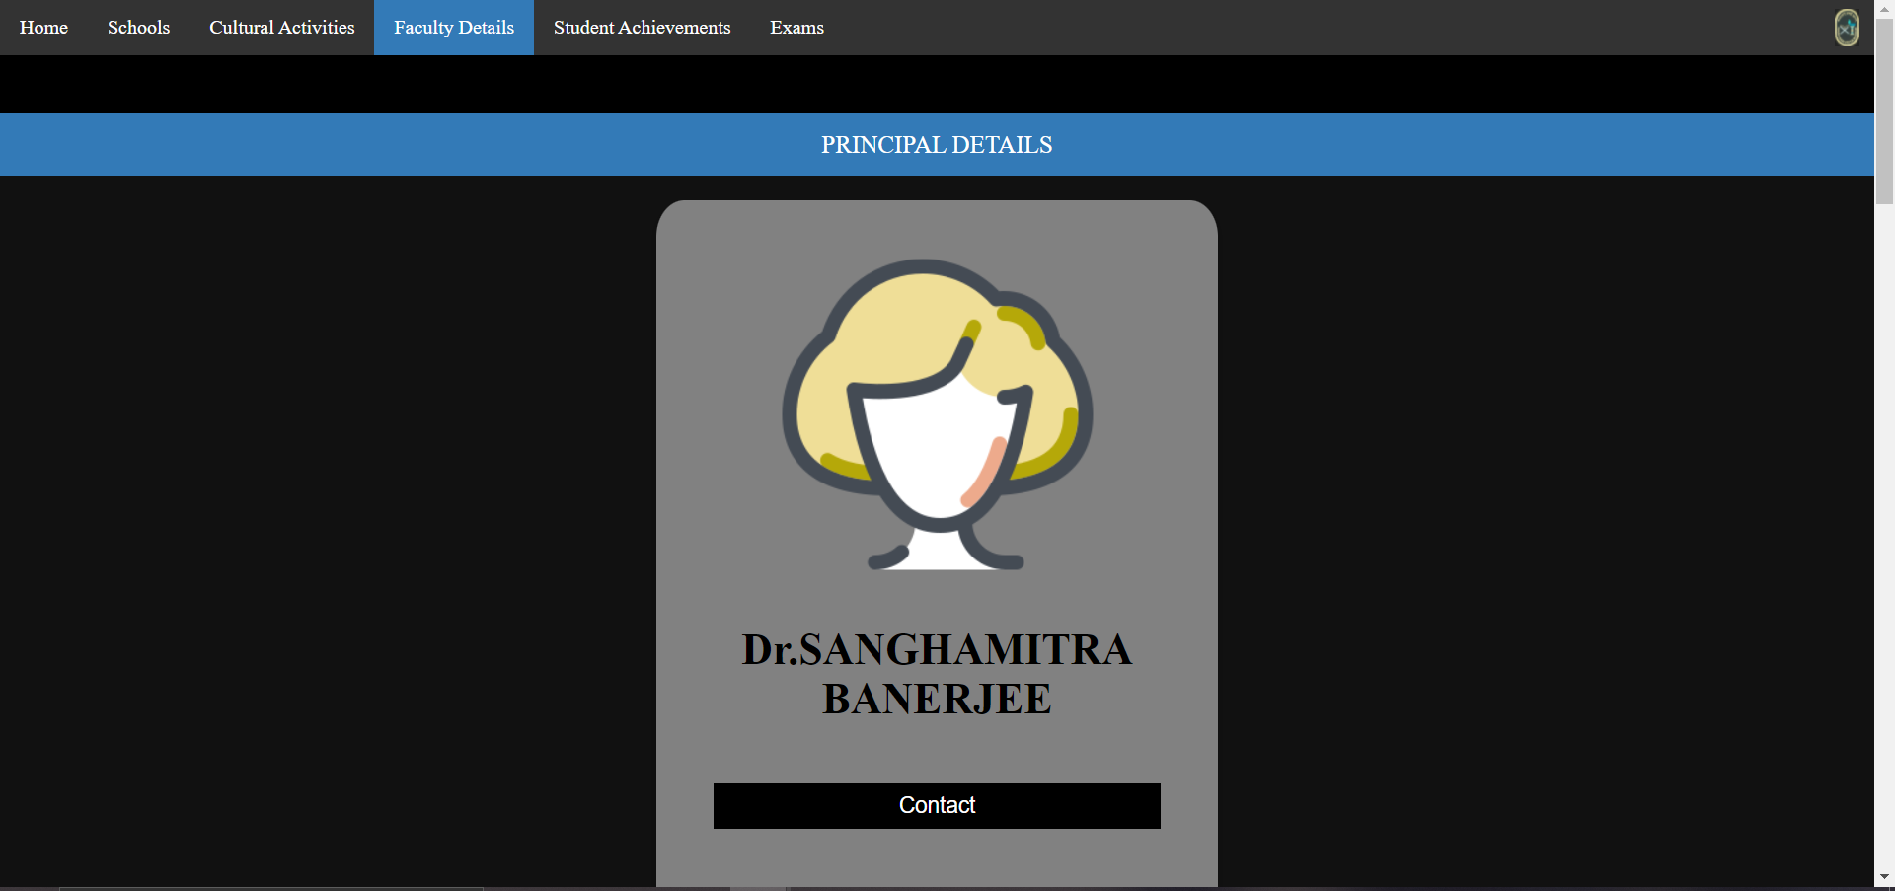

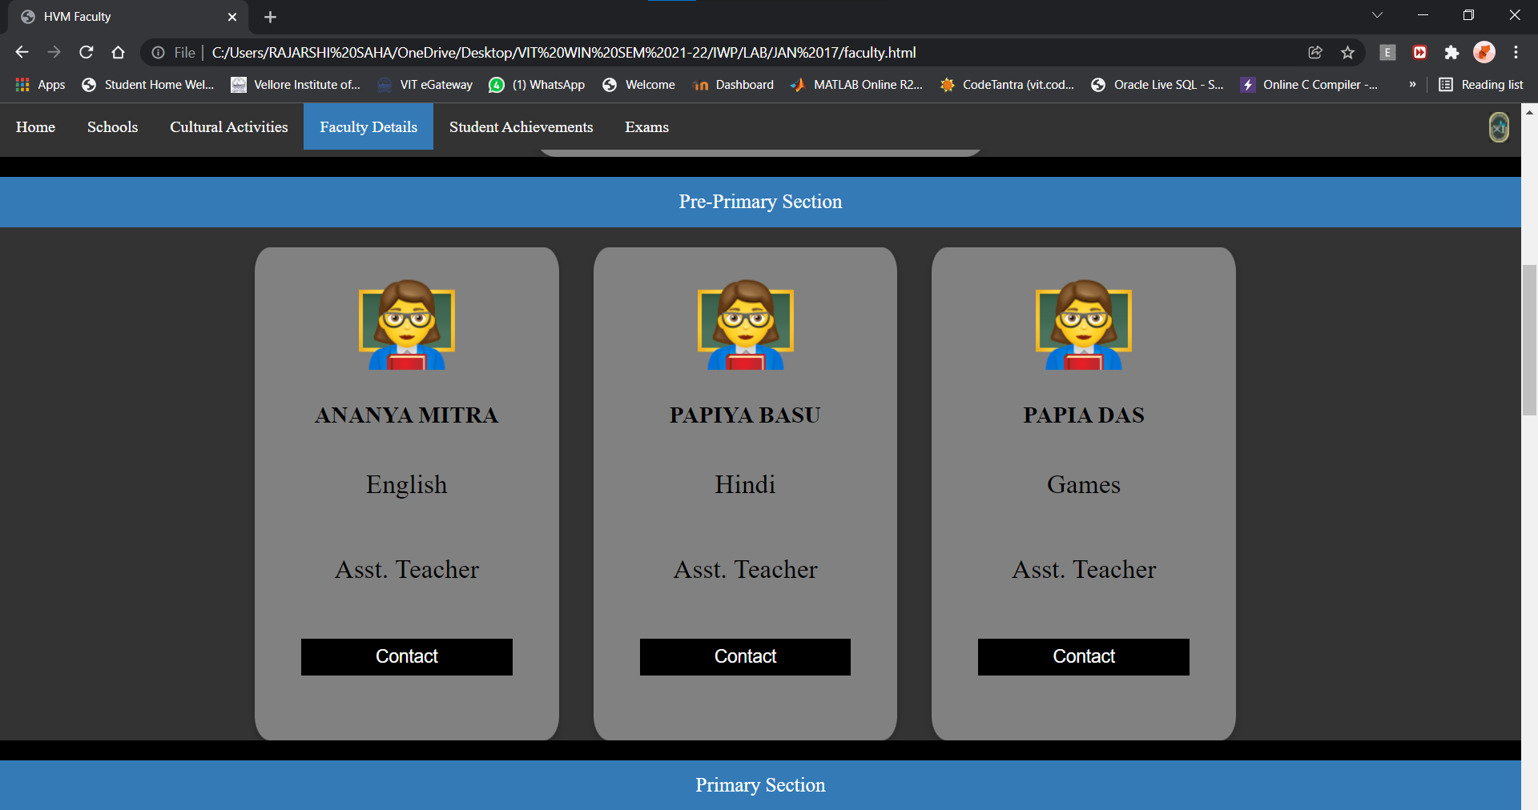

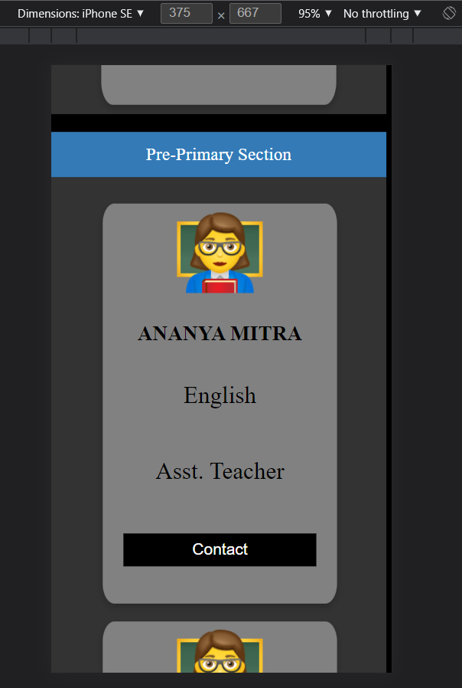

Competitive exam score/ Company accredited certificate – company details and previous year records (for ratings use input tags

Code:

<!DOCTYPE html>

<html lang="en">

<head>

    <meta charset="UTF-8">

    <meta http-equiv="X-UA-Compatible" content="IE=edge">

    <meta name="viewport" content="width=device-width, initial-scale=1.0">

    <title>Exam Timetable</title>

    <link rel="stylesheet" href="style.css">

</head>

<body>

    <div id="menu" class="menu">

        <ul>

            <li class="dropdown"><a href="index.html">Home</a>

                <div class="dropdown-content">

                    <a href="index.html#about-us">About Us</a>

                    <a href="index.html#image-map">Campus</a>

                </div>

            </li>

            <li class="dropdown"><a href="courses.html">Schools</a>

                <div class="dropdown-content">

                    <a href="courses.html#pp">Pre-Primary Section</a>

                    <a href="courses.html#pri">Primary Section</a>

                    <a href="courses.html#high">High Section</a>

                    <a href="courses.html#hs">Higher Secondary Section</a>

                </div>

            </li>

            <li class="dropdown"><a href="clubs.html">Cultural Activities</a>

                <div class="dropdown-content">

                    <a href="clubs.html#events">Upcoming Events</a>

                    <a href="clubs.html#clubs">Clubs and Chapters</a>

                    <a href="clubs.html#glory">Hall of Fame</a>

                </div>

            </li>

            <li class="dropdown"><a href="faculty.html">Faculty Details</a>

                <div class="dropdown-content">

                    <a href="faculty.html#pp">Pre-Primary Section</a>

                    <a href="faculty.html#pri">Primary Section</a>

                    <a href="faculty.html#high">High Section</a>

                    <a href="faculty.html#hs">Higher Secondary Section</a>

                </div>

            </li>

            <li class="dropdown"><a href="results.html" class="active">Student Achievements</a>

                <div class="dropdown-content">

                    <a href="results.html#comp">Competitive Exams</a>

                    <a href="results.html#boards">Boards</a>

                    <a href="results.html#sports">Sports</a>

                    <a href="results.html#glory">Others</a>

                </div>

            </li>

            <li class="dropdown"><a href="coe.html">Exams</a>

                <div class="dropdown-content">

                    <a href="coe.html#timetable">Timetable</a>

                    <a href="result.html#result">Result</a>

                  </div>

            </li>

            <li style="float:right" id="logo"><a class="logo" href="index.html"><img src="logo_hv_edited.jpg" width=20" height="30" alt="HVM logo" ></a></li>

        </ul>

    </div>

    <br><br><br><br>

    <div id="comp" class="leftcolumn">

        <div class="card">

            <center><p class="heading">Competitive Exams</p></center>

            <div id="marquee">

            <marquee scrollamount="9" scrolldelay="400" width="100%" height="700px" direction="up" onmouseover="stop();" onmouseout="start();" >

            <center>

            <p>JEE Mains Results 2021:</p>

            <p> Anirudh Vadera: 99.92 percentile</p>

            <p>State Rank: 1</p>

            <p>Marks Scored: 342/360</p>

            <p></p>

            <p> Mayukh Mondal: 99.71 percentile</p>

            <p>State Rank: 10</p>

            <p>Marks Scored: 322/360</p>

            <p></p>

            <p> Vansh Karnwal: 99.11 percentile</p>

            <p>State Rank: 29</p>

            <p>Marks Scored: 302/360</p>

            <p></p>

            <p>&nbsp;</p>

            <p>NEET Results 2021:</p>

            <p> Arshiya Vadera: 99.92 percentile</p>

            <p>State Rank: 1</p>

            <p>Marks Scored: 342/360</p>

            <p></p>

            <p> Mayushi Mondal: 99.71 percentile</p>

            <p>State Rank: 10</p>

            <p>Marks Scored: 322/360</p>

            <p></p>

            <p>&nbsp;</p>

            </center>

            </marquee>

        </div>

        </div>

    </div>

    <div id="boards" class="leftcolumn">

        <div class="card">

            <center><p class="heading">Boards</p></center>

            <div id="marquee">

            <marquee scrollamount="9" scrolldelay="400" width="100%" height="700px" direction="up" onmouseover="stop();" onmouseout="start();" >

            <center>

            <p>Class 10 Results 2021:</p>

            <p> Anirudh Vadera: 99.92 percentile</p>

            <p>State Rank: 1</p>

            <p>Marks Scored: 342/360</p>

            <p></p>

            <p>&nbsp;</p>

            <p>Class 12 Results 2021:</p>

            <p> Arshiya Dwiwedi: 99.92 percentile</p>

            <p>State Rank: 1</p>

            <p>Marks Scored: 342/360</p>

            <p></p>

            <p>&nbsp;</p>

            </center>

            </marquee>

        </div>

        </div>

    </div>

    <div id="sports" class="rightcolumn">

        <div class="card">

            <center><p class="heading">Sports</p></center>

            <div id="marquee">

            <marquee scrollamount="9" scrolldelay="400" width="100%" height="700px" direction="up" onmouseover="stop();" onmouseout="start();" >

            <center>

            <p>RFYCResults 2021:</p>

            <p>HVM Football Team</p>

            <p>State Rank: 5</p>

            <p></p>

            <p>&nbsp;</p>

            </center>

            </marquee>

        </div>

        </div>

    </div>

    <div id="glory" class="rightcolumn">

        <div class="card">

            <center><p class="heading">Others</p></center>

            <div id="marquee">

            <marquee scrollamount="9" scrolldelay="400" width="100%" height="700px" direction="up" onmouseover="stop();" onmouseout="start();" >

            <center>

            <p>Spell BEE 2021:</p>

            <p>HVM Team</p>

            <p>State Rank: 1</p>

            <p></p>

            <p>&nbsp;</p>

            </center>

            </marquee>

        </div>

        </div>

    </div>

    <div class="eop"></div>

    <div id="eop" class="map"><p class="sec"></p></div>

    <footer>

        <center><img src="footer_logo.jpg" width=66% height="150" alt="footer"></center>

    </footer>

</body>

</html>

Output:

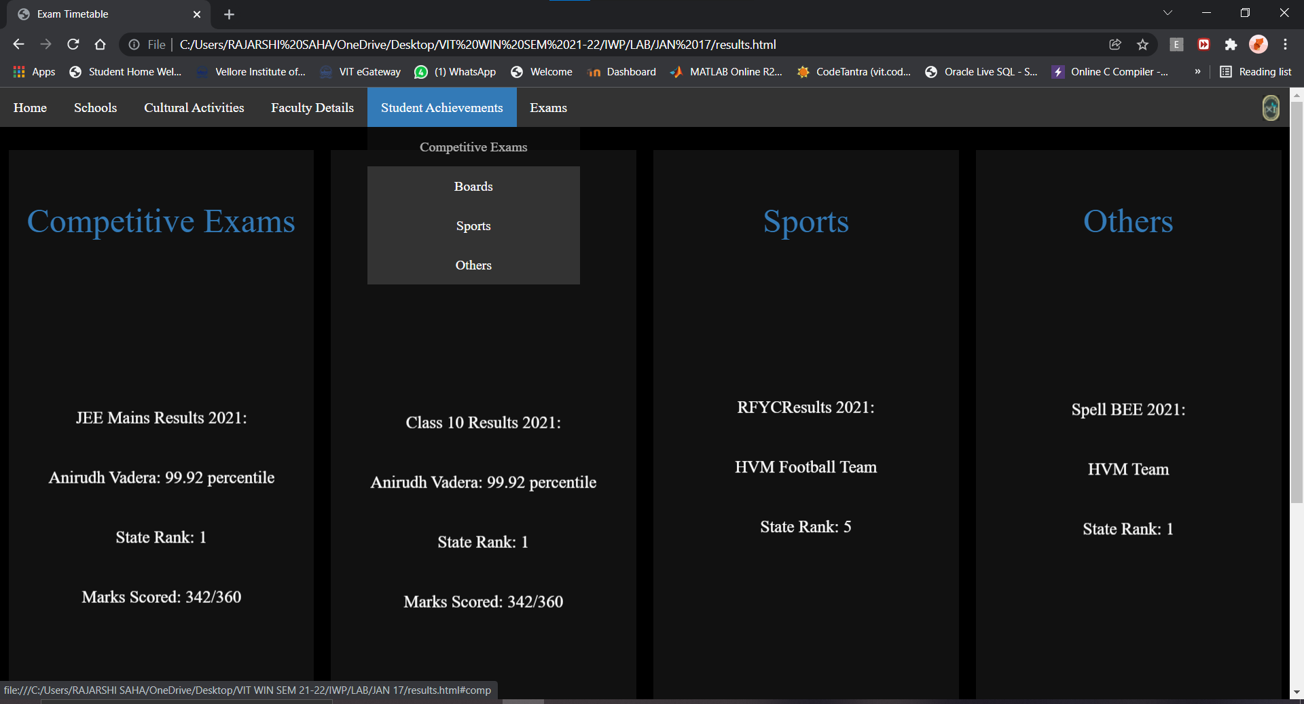

COE/Feedback form

* 1. Exam time table/project – Use table, rowspan/colspan

Code:

<!DOCTYPE html>

<html lang="en">

<head>

    <meta charset="UTF-8">

    <meta http-equiv="X-UA-Compatible" content="IE=edge">

    <meta name="viewport" content="width=device-width, initial-scale=1.0">

    <title>Exam Timetable</title>

    <link rel="stylesheet" href="style.css">

</head>

<body>

    <div id="menu" class="menu">

        <ul>

            <li class="dropdown"><a href="index.html">Home</a>

                <div class="dropdown-content">

                    <a href="index.html#about-us">About Us</a>

                    <a href="index.html#image-map">Campus</a>

                </div>

            </li>

            <li class="dropdown"><a href="courses.html">Schools</a>

                <div class="dropdown-content">

                    <a href="courses.html#pp">Pre-Primary Section</a>

                    <a href="courses.html#pri">Primary Section</a>

                    <a href="courses.html#high">High Section</a>

                    <a href="courses.html#hs">Higher Secondary Section</a>

                </div>

            </li>

            <li class="dropdown"><a href="clubs.html">Cultural Activities</a>

                <div class="dropdown-content">

                    <a href="clubs.html#events">Upcoming Events</a>

                    <a href="clubs.html#clubs">Clubs and Chapters</a>

                    <a href="clubs.html#glory">Hall of Fame</a>

                </div>

            </li>

            <li class="dropdown"><a href="faculty.html">Faculty Details</a>

                <div class="dropdown-content">

                    <a href="faculty.html#pp">Pre-Primary Section</a>

                    <a href="faculty.html#pri">Primary Section</a>

                    <a href="faculty.html#high">High Section</a>

                    <a href="faculty.html#hs">Higher Secondary Section</a>

                </div>

            </li>

            <li class="dropdown"><a href="results.html">Student Achievements</a>

                <div class="dropdown-content">

                    <a href="results.html#comp">Competitive Exams</a>

                    <a href="results.html#boards">Boards</a>

                    <a href="results.html#sports">Sports</a>

                    <a href="clubs.html#glory">Others</a>

                </div>

            </li>

            <li class="dropdown"><a href="coe.html" class="active">Student Login</a>

                <div class="dropdown-content">

                    <a href="coe.html#timetable">Timetable</a>

                    <a href="result.html#result">Result</a>

                  </div>

            </li>

            <li style="float:right" id="logo"><a class="logo" href="index.html"><img src="logo_hv_edited.jpg" width=20" height="30" alt="HVM logo" ></a></li>

        </ul>

    </div>

    <br><br><br><br>

    <div id="timetable">

        <p class="sec">EXAM<br>TIMETABLE</p>

        <br>

        <br>

        <table border="5" border="double" cellspacing="5px" class="table">

            <tr>

                <th>Sno.</th>

                <th>Subject</th>

                <th>Date</th>

                <th>Class</th>

            </tr>

            <tr>

                <td>1</td>

                <td>English</td>

                <td>28-jan-2022</td>

                <td rowspan="3">Nursey<br>LKG<br>UKG</td>

            </tr>

            <tr>

                <td>2</td>

                <td>Arts & Crafts</td>

                <td>30-jan-2022</td>

            </tr>

            <tr>

                <td>3</td>

                <td>Maths</td>

                <td>01-feb-2022</td>

            </tr>

            <tr>

                <td>4</td>

                <td>English</td>

                <td>28-jan-2022</td>

                <td rowspan="4">Classes<br>I to VIII</td>

            </tr>

            <tr>

                <td>5</td>

                <td>Social Studies</td>

                <td>30-jan-2022</td>

            </tr>

            <tr>

                <td>6</td>

                <td>Science</td>

                <td>02-feb-2022</td>

            </tr>

            <tr>

                <td>7</td>

                <td>Maths</td>

                <td>05-feb-2022</td>

            </tr>

            <tr>

                <td>8</td>

                <td>English</td>

                <td>25-jan-2022</td>

                <td rowspan="7">Classes<br>IX,X<br>XI,XII</td>

            </tr>

            <tr>

                <td>9</td>

                <td>Social Studies</td>

                <td>27-jan-2022</td>

            </tr>

            <tr>

                <td>10</td>

                <td>Physics</td>

                <td>28-jan-2022</td>

            </tr>

            <tr>

                <td>11</td>

                <td>Maths</td>

                <td>30-jan-2022</td>

            </tr>

            <tr>

                <td>12</td>

                <td>Chemistry</td>

                <td>02-feb-2022</td>

            </tr>

            <tr>

                <td>13</td>

                <td>Biology</td>

                <td>04-feb-2022</td>

            </tr>

            <tr>

                <td>14</td>

                <td>Computer Science</td>

                <td>04-feb-2022</td>

            </tr>

        </table>

    </div>

    <div id="eop" class="map"><p class="sec"> </p></div>

    <div>

        <center><img src="footer_logo.jpg" width=66% height="150" alt="footer"></center>

    </div>

</body>

</html>

Output:

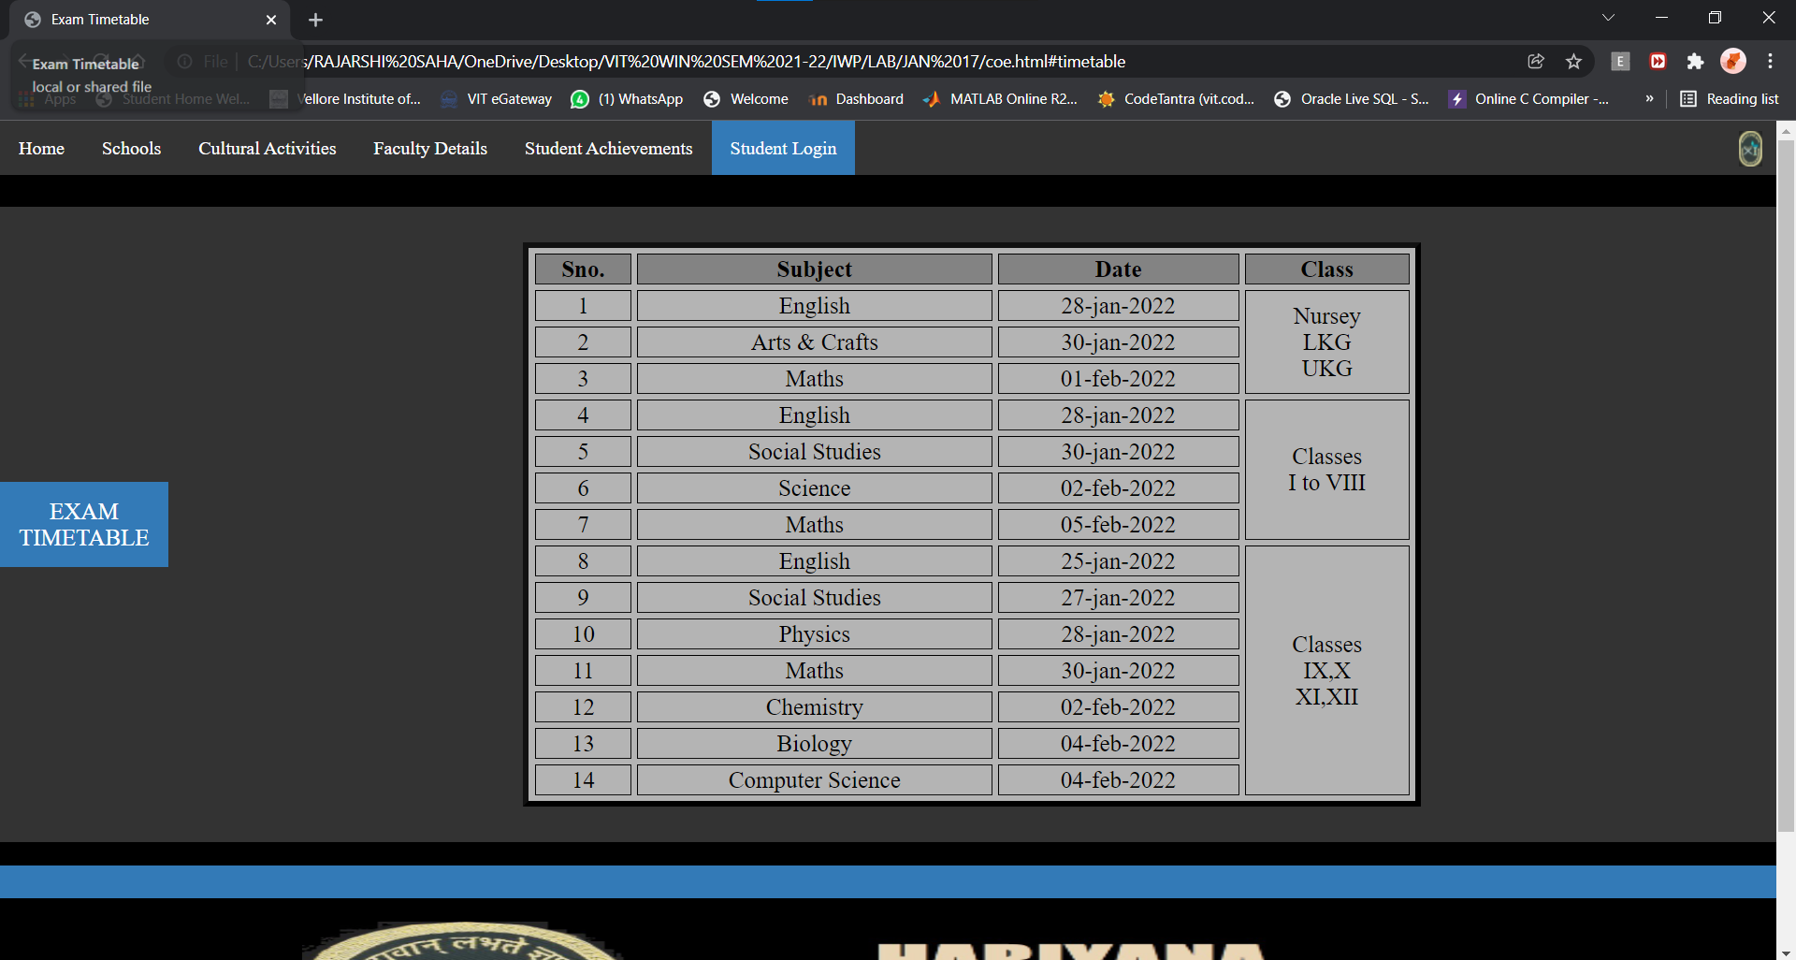

* 1. Result/feedback – use HTML5 form – Fields are name, password, DOB, email-id, Phone no and comment inputs(types/tags/pattern)

Code:

<!DOCTYPE html>

<html>

<head>

    <meta charset="UTF-8">

    <meta http-equiv="X-UA-Compatible" content="IE=edge">

    <meta name="viewport" content="width=device-width, initial-scale=1.0">

    <title>Exam Results</title>

    <link rel="stylesheet" href="https://cdnjs.cloudflare.com/ajax/libs/font-awesome/4.7.0/css/font-awesome.min.css">

    <link rel="stylesheet" href="style.css">

</head>

<body>

  <div id="menu" class="menu">

    <ul>

        <li class="dropdown"><a href="index.html">Home</a>

            <div class="dropdown-content">

                <a href="index.html#about-us">About Us</a>

                <a href="index.html#image-map">Campus</a>

            </div>

        </li>

        <li class="dropdown"><a href="courses.html">Schools</a>

            <div class="dropdown-content">

                <a href="courses.html#pp">Pre-Primary Section</a>

                <a href="courses.html#pri">Primary Section</a>

                <a href="courses.html#high">High Section</a>

                <a href="courses.html#hs">Higher Secondary Section</a>

            </div>

        </li>

        <li class="dropdown"><a href="clubs.html">Cultural Activities</a>

            <div class="dropdown-content">

                <a href="clubs.html#events">Upcoming Events</a>

                <a href="clubs.html#clubs">Clubs and Chapters</a>

                <a href="clubs.html#glory">Hall of Fame</a>

            </div>

        </li>

        <li class="dropdown"><a href="faculty.html">Faculty Details</a>

            <div class="dropdown-content">

                <a href="faculty.html#pp">Pre-Primary Section</a>

                <a href="faculty.html#pri">Primary Section</a>

                <a href="faculty.html#high">High Section</a>

                <a href="faculty.html#hs">Higher Secondary Section</a>

            </div>

        </li>

        <li class="dropdown"><a href="results.html">Student Achievements</a>

            <div class="dropdown-content">

                <a href="results.html#comp">Competitive Exams</a>

                <a href="results.html#boards">Boards</a>

                <a href="results.html#sports">Sports</a>

                <a href="clubs.html#glory">Others</a>

            </div>

        </li>

        <li class="dropdown"><a href="coe.html" class="active">Exams</a>

            <div class="dropdown-content">

              <a href="coe.html#timetable">Timetable</a>

              <a href="result.html#result">Result</a>

            </div>

        </li>

        <li style="float:right" id="logo"><a class="logo" href="index.html"><img src="logo_hv_edited.jpg" width=20" height="30" alt="HVM logo" ></a></li>

    </ul>

    </div>

    <br><br><br><br>

    <div id="result">

        <p class="sec">EXAM<br>RESULTS</p>

        <div class="card" style="margin-left: 20%; margin-right: 20%; height:auto; padding: 0 10px 50px 10px; position: relative; border-top: 10px; border-radius: 2px; border-color: #337AB7;">

            <form action="coe.html#timetablel" autocomplete="on">

                <p class="secc" style="margin-left: 0;margin-right: 0"></p>

                <h1>Login to view your results</h1>

                <div style="display: flex; width: 100%; margin-bottom: 15px;">

                <input style="width: 100%; padding: 6px 12px; outline: none; height:31px;" type="text" placeholder="Username" id="uname" name="uname" maxlength="20">

                <i style="padding: 8px; background: #2980B9; color: white; min-width: 40px; text-align: center;font-size: 15px;" class="fa fa-user icon"></i>

                </div>

                <div style="display: flex; width: 100%; margin-bottom: 15px;">

                <input style="width: 100%; padding: 6px 12px; outline: none; height: 31px;" type="password" id="passwd" name="passwd" placeholder="Password">

                <i id="psd" style="padding: 8px; background: #2980B9; color: white; min-width: 40px; text-align: center; font-size: 15px; cursor: pointer;" class="fa fa-eye-slash"></i>

                </div>

                <div style="display: flex; width: 100%; margin-bottom: 15px;">

                <input style="width: 100%; padding: 6px 12px; outline: none; height: 31px;" type="email" id="mail" name="mail" placeholder="Email Address">

                <i id="mail" style="padding: 8px; background: #2980B9; color: white; min-width: 40px; text-align: center; font-size: 15px; cursor: pointer;" class="fa fa-envelope"></i>

                </div>

                <div style="display: flex; width: 100%; margin-bottom: 15px;">

                <input style="width: 100%; padding: 6px 12px; outline: none; height: 31px;" type="number" id="phone" name="phone" placeholder="Phone Number">

                <i id="mail" style="padding: 8px; background: #2980B9; color: white; min-width: 40px; text-align: center; font-size: 15px; cursor: pointer;" class="fa fa-phone"></i>

                </div>

                <div style="display: flex; width: 100%; margin-bottom: 15px;">

                <input style="width: 100%; padding: 6px 12px; outline: none; height: 31px;" type="date" id="dob" name="dob" value="2000-01-01" max="2003-12-31" placeholder="Date of Birth">

                <i id="mail" style="padding: 8px; background: #2980B9; color: white; min-width: 40px; text-align: center; font-size: 15px; cursor: pointer;" class="fa fa-calendar"></i>

                </div>

                <br><br><br>

                <div class="submit">

                    <input class="submit-btn" type="submit" name="Submit" value="Submit">

                    <input class="submit-btn" type="reset" name="Submit2" value="Reset">

                </div>

                </form>

    </div>

    </div>

    <div id="eop" class="map"><p class="sec"> </p></div>

    <div>

        <center><img src="footer_logo.jpg" width=66% height="150" alt="footer"></center>

    </div>

</body>

</html>

Output:

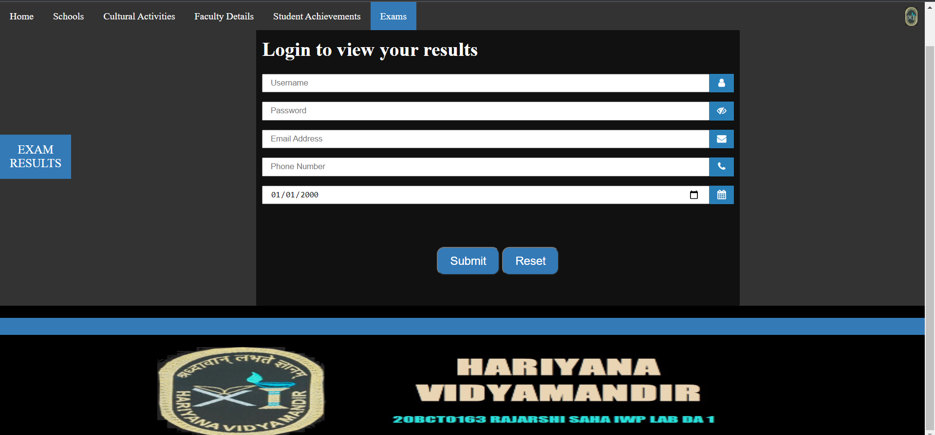

**Common Style Sheet for all the html pages**

body {

*background-color*: black;

*margin*:0;

}

/* #logo{

    padding:5px 5px;

} */

* {

*box-sizing*: border-box;

}

p {

*display*: block;

*font-size*: 15pt;

*color*: white;

*text-align*: center;

*padding*: 14px 16px;

*text-decoration*: none;

}

p.heading{

*display*: block;

*font-size*: 13pt;

*color*: #337AB7;

*text-align*: center;

*padding*: 0;

}

p.text{

*display*: block;

*font-size*: 12pt;

*color*: white;

*text-align*: justify;

*padding*: 20px;

}

ul {

*list-style-type*: none;

*overflow*: hidden;

*margin*:0;

*padding*:0;

}

.map img.map {

*margin*: 0;

*padding*: 0;

*background-color*: #333;

*width*: auto;

*height* : auto;

*max-height*: 100%;

*max-width*: 100%;

}

.map{

*margin*: 0;

*padding*: 0;

*border*: 2px #333;

*background-color*: #333;

*outline-style*: outset;

}

.menu{

*position*: fixed;

*justify-content*:center;

*background-color*: #333;

*width*: 100%;

*display*: inline-block;

*z-index*:100;

}

.menu li {

*float*: left;

*justify-content*: center;

*align-items*: center;

}

.menu li a{

*display*: inline-block;

*color*: white;

*text-align*: center;

*padding*: 14px 16px;

*text-decoration*: none;

}

.menu li a.logo {

*display*: flex;

*padding*: 9px 12px 0 0;

    /* padding: 0 10px 0 0;

    margin: 10px; */

}

.menu li a.active {

*background-color*: #337AB7;

}

p.sec{

*background-color*: #337AB7;

}

.menu li a:hover{

*background-color*: #111;

}

.map:hover {

*background-color*: #111;

}

p.text:hover {

*background-color*: #111;

}

.menu li.dropdown {

*display*: block;

*overflow*: hidden;

  }

.dropdown-content{

*display*: none;

*position*: absolute;

*z-index*: 1000;

  }

.dropdown-content a {

*color*: white;

*text-decoration*: none;

*text-align*: justify;

*background-color*: #333;

*display*: block;

*width*:250px;

  }

.dropdown-content a:hover {*background-color*: #111}

.dropdown:hover .dropdown-content {

*display*: block;

*width*:100px;

  }

.leftcolumn {

*float*: left;

*position*:relative;

*width*: 25%;

*background-color*: black;

*padding*: 0 10px 0 10px;

}

.midcolumn {

*float*: left;

*position*:relative;

*width*: 50%;

*overflow-y*: auto;

*overflow-x*: hidden;

*background-color*: black;

*padding*: 0 10px 0 10px;

}

.rightcolumn {

*float*: left;

*position*:relative;

*width*: 25%;

*background-color*: black;

*padding*: 0 10px 0 10px;

}

@media screen and (*max-width*: 500px) {

.menu{

*position*:relative;

}

.menu li {

*display*: flex;

*align-items*: center;

*justify-content*: center;

*width*: 100%;

*padding*:0;

*position*:relative;

*float*:center;

    }

.menu li.dropdown{

*display*: flex;

*align-items*: center;

*justify-content*: center;

    }

.menu li.dropdown:hover .dropdown-content {

*display*: flex;

*align-items*: center;

*justify-content*: center

    }

}

@media screen and (*max-width*: 800px) {

    .leftcolumn, .midcolumn, .rightcolumn {

*width*: 100%;

*padding*: 0 0 10px 0;

*position*: relative;

    }

    .fac_card, .princ_card {

*width*: 70% !important;

*position*: relative;

*display*: block;

*margin*: 10px;

    }

    .faculty-bck{

*padding*: 0;

    }

}

.card{

*margin*: auto;

*position*: sticky;

*margin*: 0;

*overflow*: hidden;

*display*: inline-block;

*background-color*: #111;

*width*:100%;

*height*:750px;

*font-size*: 12pt;

*color*: white;

*text-align*: justify;

*padding*: 20px;

}

.card p.heading{

*display*: inline-block;

*font-size*: 30pt;

*color*: #337AB7;

*text-align*: center;

*padding*: 0;

}

#timetable, #result{

*background-color*: #333;

*margin*: 0 !important;

*display*: flex;

*align-items*: center;

*justify-content*: center;

*overflow*: auto;

}

#timetable:hoverr{

*background-color*: #111;

}

.table{

*margin-top*: 2%;

*margin-left*: 20%;

*margin-right*: 20%;

*margin-bottom*: 2%;

*width*: 60%;

*color*: black;

*font-size*: 15pt;

*background-color*: #b4b4b4;

*text-align*: center;

*border-color*: #111;

}

th{

*background-color*: #838383;

}

.forms{

*margin-left*: 20%;

*margin-right*: 20%;

*padding-bottom*: 5%;

*margin-bottom*: 2%;

*margin-top*: 2%;

*width*: 60%;

*color*: black;

*font-size*: 1.5rem;

*background-color*: #b4b4b4;

*border-color*: #111;

*border-radius*: 5%;

*border-width*: 2%;

}

.secc{

*margin*: 0 !important;

*background-color*: #337AB7;

}

.submit-btn {

*-webkit-border-radius*: 12;

*-moz-border-radius*: 12;

*border-radius*: 12px;

*font-family*: Arial;

*color*: #ffffff;

*font-size*: 19px;

*background*: #337AB7;

*padding*: 10px 20px 10px 20px;

*text-decoration*: none;

*text-align*: center;

  }

  .submit-btn:hover {

*background*: #3cb0fd;

*text-decoration*: none;

  }

  .submit{

*text-align*: center;

  }

.princ_card {

*box-shadow*: 0 4px 8px 0 rgba(0, 0, 0, 0.2);

*width*: 30%;

*position*: relative;

*border-radius*: 5%;

*background-color*: #818181;

*padding*: 3% 2% 3% 2%;

*font-size*: 30px;

*display*: inline-block;

  }

.fac_card{

*box-shadow*: 0 4px 8px 0 rgba(0, 0, 0, 0.2);

*width*: 20%;

*margin-right*:2% ;

*position*: relative;

*background-color*: #818181;

*border-radius*: 5%;

*padding*: 2%;

*font-size*: 20px;

*display*: inline-block;

}

.princ_card:hover, .fac_card:hover{

*background-color*: #b4b4b4;

}

button {

*border*: none;

*outline*: 0;

*display*: inline-block;

*padding*: 8px;

*color*: white;

*background-color*: #000;

*text-align*: center;

*cursor*: pointer;

*width*: 100%;

*font-size*: 18px;

  }

  .fac_card a,.princ_card a {

*text-decoration*: none;

*font-size*: 22px;

*color*: black;

  }

  button:hover, a:hover {

*opacity*: 0.7;

  }

  .faculty-bck{

*background-color*: #333

  }

  .faculty-bck:hover{

*background-color*: #111;

  }

  .faculty-sec{

*background-color*: #337AB7;

  }

  #principal, #pp, #pri, #high, #hs{

*text-align*: center;

  }

  .faculty-img{

*border-radius*: 50%;

*height*: 100px;

*width*: 5px;

  }

  .faculty-txt{

*color*: black;

*font-size*: 20pt;

  }

    #halloffame{

*height*: 100%;

*position*: relative;

*overflow*: hidden

    }

  #halloffame > * {

*height*: 100%;

*box-sizing*: border-box;

*overflow*: hidden

    }

    #halloffame > *:first-child {

*animation*: 12s autoplay1 infinite ease-in-out}

      @keyframes *autoplay1* {

        0% {*margin-top*: 700px}

        5% {*margin-top*: 0px}

        25% {*margin-top*: 0px}

        30% {*margin-top*: -700px}

        50% {*margin-top*: -700px}

        55% {*margin-top*: -1400px}

        75% {*margin-top*: -1400px}

        80% {*margin-top*: -2100px}

        95% {*margin-top*: -2100px}

        100% {*margin-top*: -2800px}

      }

#clubs {

*height*: 100%;

*position*: relative;

*display*: flex;

*overflow-x*:auto ;

*width*: 100%;

}

#clubs > * {

*height*: 100%;

*width*: 25%;

*box-sizing*: border-box;

*overflow*: hidden

    }

#clubs  > *:first-child {

*animation*: 6s autoplay3 infinite ease-in-out}

    @keyframes *autoplay3* {

    0% {*margin-left*: 2100px}

    25% {*margin-left*: 0px}

    75% {*margin-left*: 0px}

    100% {*margin-left*: -2100px}

}

#imgs {

*height*: 200px;

*position*: relative;

*display*: flex;

*overflow-x*:auto ;

*width*: 100%;

}

#imgs> * {

*height*: 200px;;

*width*: 25%;

*box-sizing*: border-box;

*overflow*: hidden

}

#imgs  > *:first-child {

*animation*: 6s autoplay3 infinite ease-in-out}

@keyframes *autoplay3* {

0% {*margin-left*: 2100px}

25% {*margin-left*: 0px}

75% {*margin-left*: 0px}

100% {*margin-left*: -2100px}

}

.eop:after{

*content*: "";

*display*: table;

*clear*: both;

}